https://www.maketecheasier.com/free-graphic-editor-for-creating-vector-image/:
6 of the Best Free Graphics Editors for Creating Vector Images

5. LibreOffice Draw
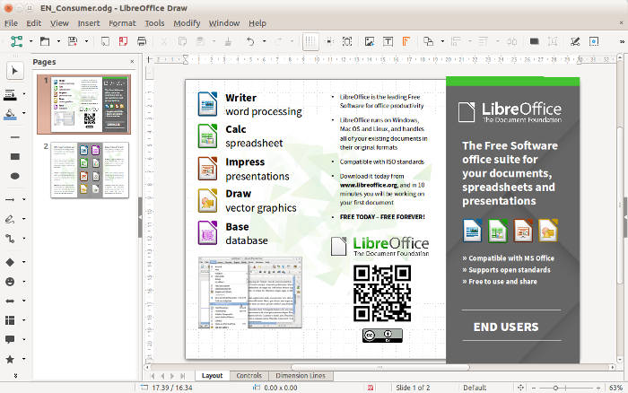
LibreOffice Draw is a good desktop vector editor for Linux, Windows, and Mac. It’s worth trying, especially if you already use the LibreOffice suite. You can use it to create vector images from scratch or to modify existing ones. One of the cool uses of LibreOffice Draw is for technical drawings, flowcharts, and diagrams because it has the right tools for the purpose. For more complex graphic editing, I personally prefer Inkscape.
https://www.libreoffice.org/discover/draw/:
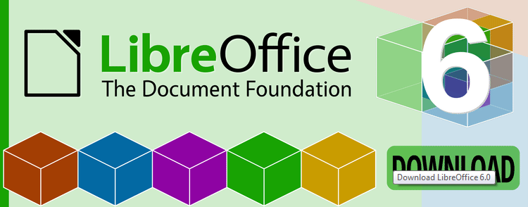

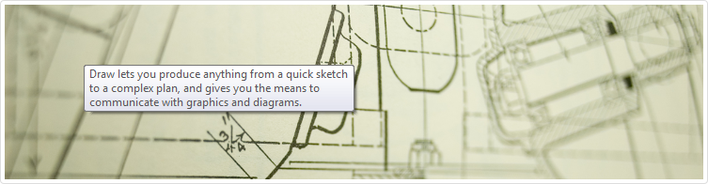
Draw anything from the simple to the complex with LibreOffice Draw.
LibreOffice Draw is part of the LibreOffice productivity suit that is similar to Microsoft Office for your computer only it is free and open source. This freeware feature lets you draw simple animations like quick sketches to the more complex ones like technical drawings, posters, graphs and diagrams. It features various drawing tool, 3D controller, smart connectors, rendering, clip art and many more. Your work can be exported to Flash format and import graphics from more common formats like JPEG, TIFF, PNG and many more.
Draw and create works using an all purpose, convenient and practical drawing suite with LibreOffice Draw.
Download – URL:
http://download.documentfoundation.org/libreoffice/stable/3.6.0/win/x86/LibO_3.6.0_Win_x86_install_multi.msi

